Homework #2 - PS 1 due 9/22/2021

Problems below make use of the northwind dataset (northwind db). Please feel free to consult your notes, the lectures and email me and/or the class TA for help. While you may work together, it is highly advisable that you attempt to do the problems alone (i.e. not with )a fellow classmate so that you may best identify which area(s) you would like to spend more time discussing.

** Note ** The acronym CI refers to case-insensitive. So if you see it near a word, it means perform a case-insensitive search.

# QUESTION 1

In the customers table, group by country and contact_title fields where the contact_title field does not have the word 'sales' (CI) in it and return the count of items in the grouping as "total". Return groupings with a total greater than 2 and sort the result by the country and contact_title fields descending.

*Sample of results*

# 

# QUESTION 2

In the order_details table, group on the order_id and discount fields. Compute the following: average of the quantity field as “avg_quantity” & round it to two decimal places; the sum of the unit_price field as “sum_price”, and the count of the number of items in the grouping as “total”. Filter on rows where the total field is greater than four and the discount is greater than zero. Sort by the total and discount fields both descending.

*Sample of results*

# 

# 

# 

# 

# QUESTION 3

In the customers table, group by the contact_title, and return the count per grouping, the maximum value of the city field as mx_city, the minimum value of the city field as mn_city, and the length of the minimum city field subtracted from the length of maximum city field (i.e. max - min) as city_diff.   
  
Only group the rows where the contact_title of a row contains the word 'owner'(CI) or 'representative' (CI). Sort by the total descending and the mx_city descending.

*Note* max() and min() when used on a string evaluates a set of values in alphabetical order i.e. in other words, MAX( ‘Art’, ‘Board’, ‘Cat’) would return the word ‘Cat’, whereas MIN() would return the word ‘Art’.

*Full list of results below*

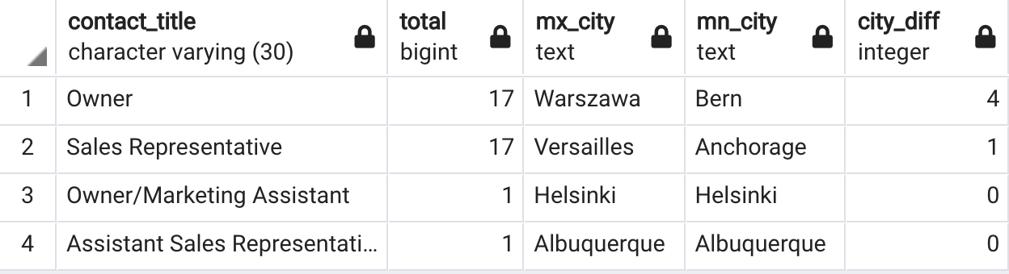

# QUESTION 4

In the products table, select the product_id ,category_id, product_name, and units_in_stock where the product_id is (condition 1) equal to the category_id or is equal to the product_id multiplied by the category_id, and (condition 2) the product_name starts with an 's' (CI) or starts with a 'u' (CI).

Sort by where the product_id is equal to the category_id ascending, and the product_name descending.

*Full results below*

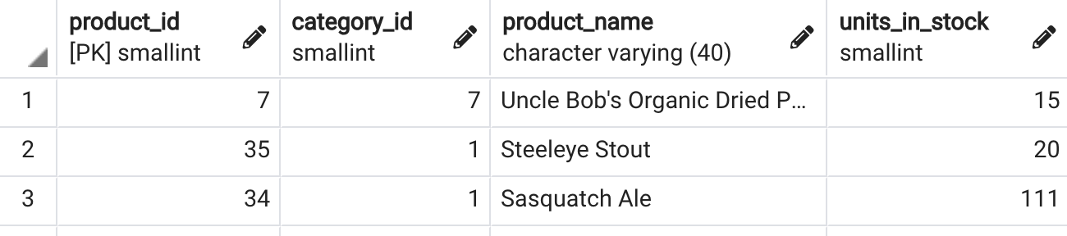

# 

# QUESTION 5

In the orders table, group by ship_via, employee_id, ship_country fields, where the ship_via is less than the employee_id and (condition 1) the ship_country does not end in the letter 'y'(CI) or 'L' (CI) or (condition 2) the employee_id is 4.

For each grouping, return the count of the number of items as total and the average freight as avg_fr. Return groupings with avg_fr greater than 30, a total greater than 7, and sort the results by total descending.

*Sample of results*

